Case Study 1.5: CGM quality with 2 x G6 overlapping V 2.3
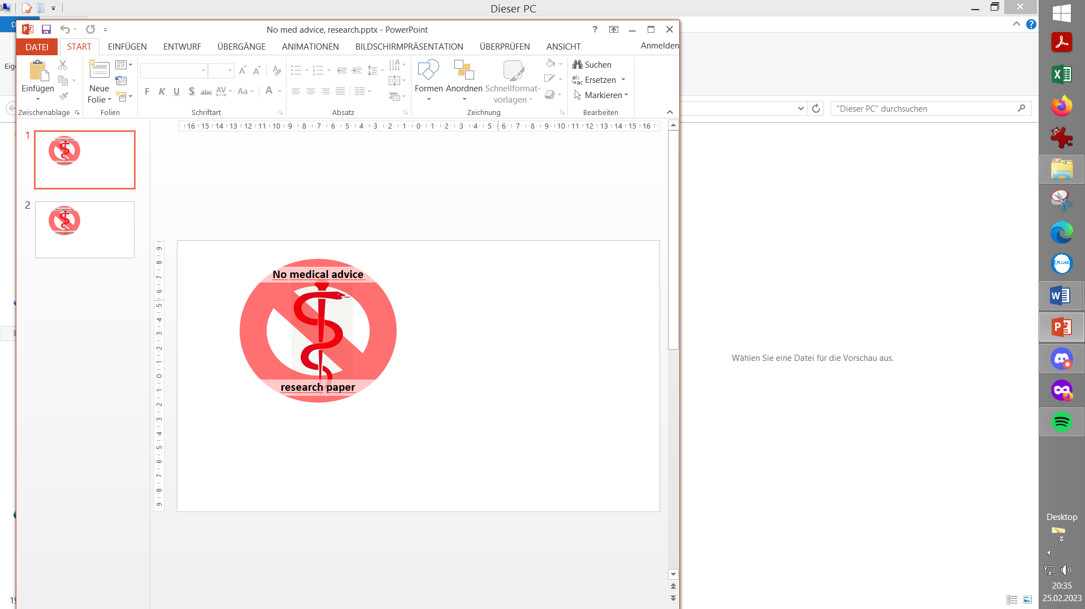

Overlapping use of two G6 allows to switch AAPS to the
smoother performing sensor, as required for FCL

Often, in the first hours after starting a new G6 sensor, CGM values are quite instable, and may also come with systematic errors in magnitude up to 50 mg/dl.

This screenshot shows:

Left side (G6 on left arm, ~ 9 d old w&/regular Tm)
shows smooth slight rise in last 4.2 hours :
Right side (G6 on right arm, w/Anubis) was started 4.2 hours ago, runs initially very much higher, much more un-steady, and overall in the opposite direction:
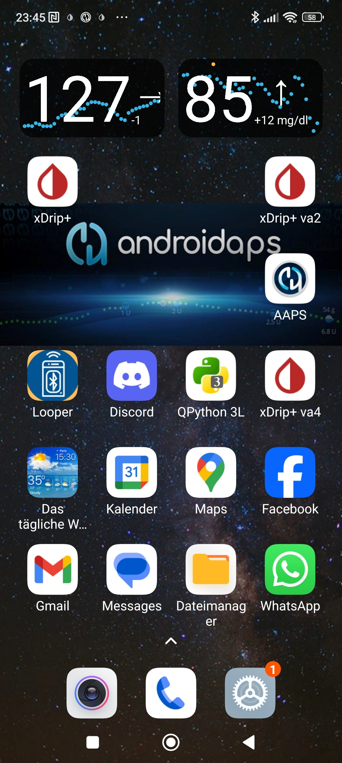
4.2 hours before 23:45
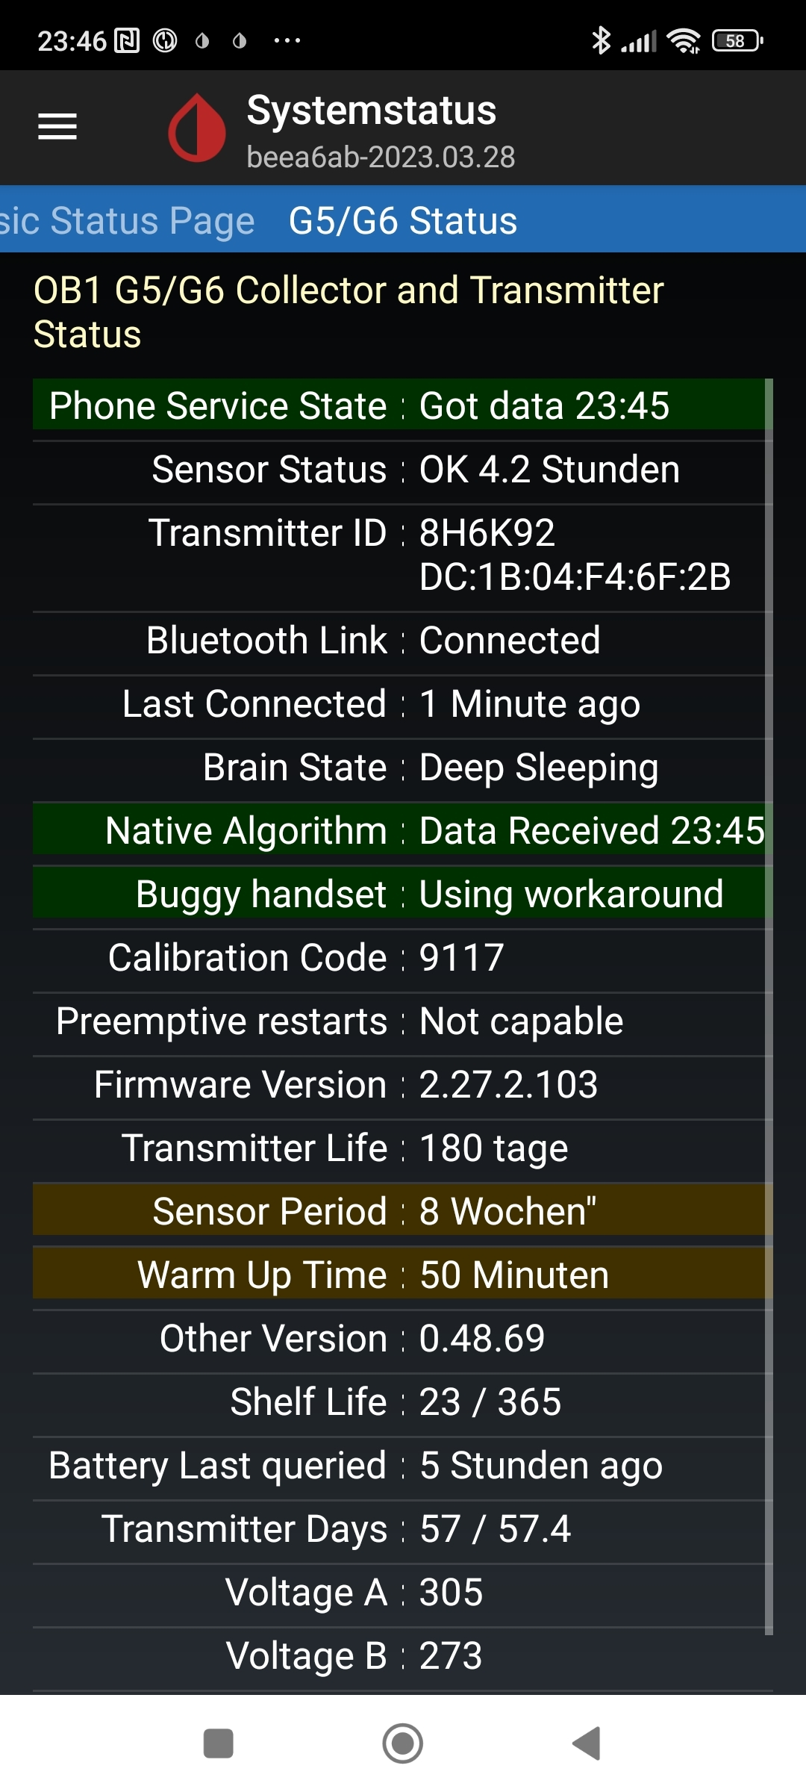

In the next 9 hours that followed (during the night), the new sensor smoothened, and was ready-for-use when, at 10.0 days, the left one literally dropped out:
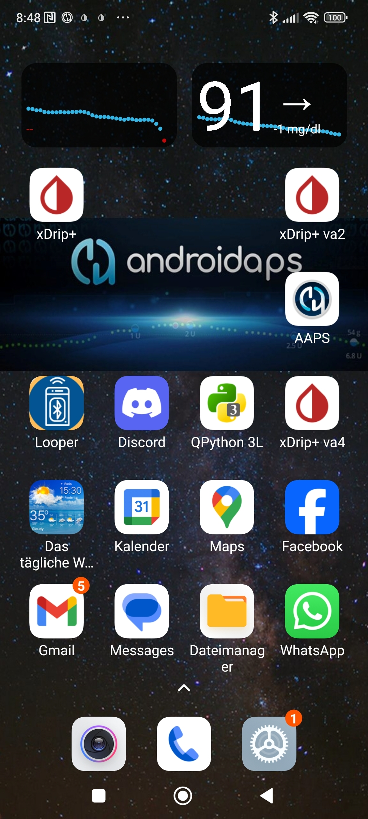

In the example shown, the new G6 on the right side arm looks good now. But it was clearly not useable for full closed looping in the first 5-6 hours after it had delivered first value, it performed nicely thereafter.
This is why overlapping use of two G6 is a recommended CGM set-up for FCL.

In case you have no second, better performing, sensor to switch over to:
- Best, exit “autoISF adaptation of ISF to glucose behavior” until you see smooth CGM performance again!
- Some seem to frequently do calibrations, in order to bridge periods of bad performance. (The author cannot comment how safe that is).
- You might also consider, to make sensor changes only at bedtime, after dinner-related bg settled + safeguard against the FCL acting on false-high values, e.g. by disabling SMBs via a odd TT.
- Open Loop or HCL is yet another option. Here you must decide whether setting different TT, different %profile, odd TT to disable SMBs, get you to a sufficiently safe and worthwhile bridging solution.
In any case, be prepared to do a couple of bg tests using test strips, to guide you.

Below is described, how an overlapping system can be set up.
Overlapping G6 (right and left arm) to warrant loopable data
Caution
Extending sensor life via using DIY modified transmitters (with pre-emptive restarts of sensors) is highly convenient but off-label and clearly on own risk. To the extent not controlled in parallel by values from the other arm, blood glucose measurements should be done in potentially critical instances to verify good performance.
There should not be a need to extend beyond just a few days. As in FCL we also must have an eye on smooth CGM performance, this leaves the risk of bad values low. Care is also required not to lose the sensor and transmitter mechanically. (Eye lash glue + Physio Tape or the Dexcom-supplied over-patch work well for me).

Mode that is financially feasible

Overlapping use of two G6 systems for continuous loopable CGM values is possible with a regular (in Germany reimbursed) G6 supply, if one (modified 81-type or) Anubis transmitter is additionally available.
Right arm: Transmitter Tm1 is a (81-type or) Anubis, that allows battery replacement, hard resets, and preemptive restarts, so it is easy to get well over 10 day sensor usage. (Transmitter runs several months before battery must be changed). Sensor runs well at least 17 days in my experience, so day 15 new sensor is started on the other (left) arm.
Left arm: Transmitter Tm2 can be from the regular reimbursed supply, and lasts only around 100 days once first-time used. Limitation with this transmitter is, that only 10.0 days uninterrupted values can be obtained for each sensor.
So it is necessary, to get the right arm ready (using the other, Anubis, transmitter again) on day 9, latest
Note that extending sensor life on the left arm beyond 10.0 d makes no sense:
- after 10.0 days a warm-up break, and often several hours of bad values, (necessary calibrations) would follow
- that would leave me for hours without “smooth” values.

The resulting usage pattern, in days of using glucose values from either, would be about:
R16+L8 That sequence would occur 16 times each year, needing 32 sensors (we receive one per 10 days reimbursed, so OK). Besides our (81 Tm or) Anubis, we can manage with the 4 regular transmitters we get per year.
If the 81type/Anubis runs minimum 17 days, one could manage with only 3 regular Tm:
365 – 17 – 17 = 331 days must be covered with 3 Tm
That would work if 3x100 days are spaced by 2x 17 days where only the 81-type/Anubis Tm is running.
Evidently, operating with TWO Anubis could make life even easier, although then entirely (as opposed to only intermittently) off-label

The overall set-up can be done if each transmitter has its own xDrip or xDripVariant instance (Option A). xDrip Variant see: https://drive.google.com/drive/folders/0B6mvYVNVC-fOWkxnVF80dlFabjQ?resourcekey=0-ebguuiPuB1wUI9Rp2zjMNg
If desired, a Dexcom app (BYODA) can also be used (Option B or C)
BYODA see: https://www.patreon.com/byod/about

Implementation Option A, with AndroidAPS and xDrip+ Variants
Data flow for bg values in Option A is as follows: (R right and L left arm)
R: G6 w/Tm-1 (Anubis) -> xDrip -> AAPS (xDrip inter-app communication active)
-> Nightscout (xDrip cloud upload active) -> xDripVar4
running for ~ 16 - max 22days.
On ~ d14, start new G6 on L arm using Tm-2 (regular or 2ndAnubis)…
L: G6 w/Tm-2 -> xDripVar2 -> value first day(s) only on phone widget
After the values from Tm-2 became reliable (anywhere between 5 and 36 hours after sensor start, i.e. likely on day 15 of the other sensor): make inter-app communication and Cloud upload R in-active (R values only show on phone widget now), and immediately then:
L: G6 w/Tm-2 -> xDripVar2 -> -> AAPS (xDrip_V2 inter-app communication active)
-> Nightscout (xDrip_V2 cloud upload active) -> xDripVar4
On late d8 or early d9 of the L sensor (in case of two Anubis, on ~d14), start over with the next sensor on the R arm ….
As already mentioned in the text above, the following Settings in xDrip and xDripVar2 must be switched every ~9…14 days, one ON -> OFF , the other OFF -> ON:
- in /Settings/Cloud Upload/Activate RestAPI (ON for sending, or OFF for not sending glucose data to NS) (Do never activate /more options/upload trtmts, because they would be duplicated in NS)
- in /Settings/Inter-App Settings/Local Broadcast (ON for sending, OFF for not sending from this Tm to AAPS)
The suggested back-end, Nightscout -> xDripVar4, is optional. I add that for easy checks on my 7, 30 and 90 day statistics right on the smartphone
This can NOT be checked on your xDrip and xDripVar2, because there, crappy values as well as gaps without any values are contained. Without xDripVariant4 back-end, you need to go into Nightscout (and Nighscout Reporter) for data analysis. Or of course on your PC, for logfile analysis from AAPS.

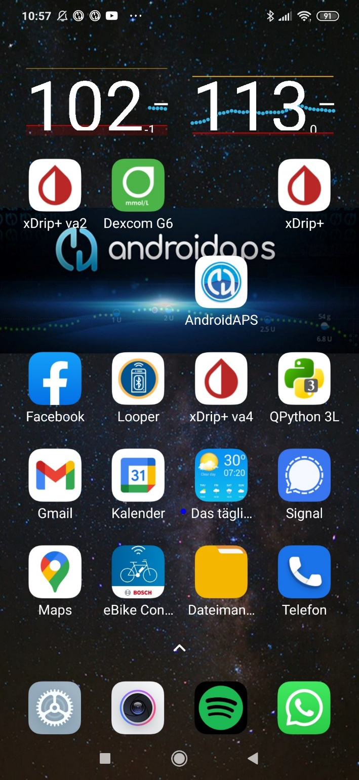
Smartphone main screen with left arm and right arm glucose values
The xDripVar4 back-end is not a necessary part of the set-up. But it allows to draw the xDrip statistics that I like to see regularly on my phone. A rolling 7day and monthly data set allows me to assess quickly how I am doing, and in which times of day improvements should be targeted. That would be not as easy in Nightscout.

Settings in xDrip in Option A:
xDrip+ xDripVar2 xDripVar4
Hardware Data Source G5/G6 Transm. G5/G6 Transm Nightscout Follower
Dexcom Transm. Anubis. number of regular Tm n/a
Treatments info OFF (coming fr.AAPS) OFF (coming fr.AAPS) Download trtmts. ON
Inter-App ON or OFF OFF or ON always OFF
Cloud Upload ON or OFF OFF or ON always OFF
Implementation Option B. with AndroidAPS, and BYODA (also requiring xDrip and a Variant)
If desired, the BYODA can additionally be used for one side (preferably for the one with „official“ use, i.e. not the Anubis side):
Glucose data flow is similar, but one side uses BYODA primarily:
R: G6 w Anubis -> xDrip -> AAPS
-> Nightscout -> xDripVar4 ……
L: G6 Tm (regular) ->BYODA -> xDripVar2 -> AAPS
-> Nightscout -> xDripVar4 ……
Settings in xDrip in option B:
xDrip+ xDripVar2 xDripVar4
Hardware Data Source G5/G6 Transm. 640G/Eversense Nightscout Follower
Dexcom Transm. Anubis…….. n/a (enter via BYODA) n/a
Treatments info OFF (coming fr.AAPS) OFF (coming fr.AAPS) Download trtmts. ON
Inter-App ON or OFF OFF or ON always OFF
Cloud Upload ON or OFF OFF or ON always OFF

Implementation Option C: All values goes through BYODA into AAPS
To maximize utilization of the Dexcom app, use one BYODA app installation on your phone as follows: (glucose data flow)
R: G6 Tm-1 (Anubis) -> BYODA -> AAPS (xDrip inter-app communication active)
-> Nightscout (xDrip cloud upload active) -> xDripVar4
running for ~ 16 - max 22days.
On ~ d14, start new G6 on L arm using Tm-2 (regular or 2ndAnubis)…
L: G6 w/Tm-2 -> xDripVar2 -> value first day(s) only on phone widget
After the values from Tm-2 became reliable (anywhere between 5 and 36 hours after sensor start, i.e. likely on day 15 of the other sensor):
- disconnect Tm-1 from BYODA, and connect Tm-2 to BYODA (other Tm number)
- in case you like to keep Tm-1 sensor running for a couple of more days, and continue to see the Tm-1 bg values, then hook up Tm-1 to xDrip (giving results on phone widget, as in screenshots shown above).
then:
L: G6 w/Tm-2 -> BYODA -> -> AAPS
-> Nightscout -> xDripVar4
On late d8 or early d9 of the L sensor (in case of two Anubis, on ~d14), start over with the next sensor on the R arm, using xDrip and the related widget to see the results on your smartphone screen .
When R gets better than L (latest when L runs out), couple with BYODA instead of xDrip …
As in the other options, the back-end, Nightscout -> xDripVar4, is optional
Settings in BYODA resp. xDrip in option C:
Note: xDrip R resp. xDripVar2 L are only used to start new sensors. Connection of sensor to AAPS always via BYODA
BYODA xDrip+, xDripVar2 xDripVar4
BG Source in AAPS/Config: BYODA in xDrip: G5/G6 Transm Nightscout Follower
Dexcom Transm. Tm of “better” sensor…….. Anubis; regular or 2nd A. n/a
Treatments info OFF (coming fr.AAPS) OFF (coming fr.AAPS) Download trtmts. ON
Inter-App to AAPS always OFF always OFF
two xDrip phone widgets
Cloud Upload ON always OFF always OFF

Additional use of Dexcom receiver

For the left arm (10 day utilization of sensors with new transmitters, as suggested by manufacturer) I usually run the Dexcom Receiver in parallel. This gives me a glucose value purely following manufacturers labelling (instructions).

Extended use of sensors?

Also with new, un-altered transmitters, extended use after 10 days is possible. This requires clipping out the transmitter for about 20 minutes.
However, a „fake“ new sensor start must follow, with a 2 hour block-out of having no glucose values (which is precisely what we want to avoid here).
So I do not do this, but - on my left arm - strictly use as suggested by manufacturer.
I would suggest a second Anubis if for some reason you want to extend sensor life on both arms.

Closing remark

Dexcom announced that mid 2026 they will begin to phase out supplying G6.
Their G7 allows a couple of hours of extension and overlap, but this will likely be inferior.
It may be worth accumulating several month of oversupply, and potentially to exchange newly prescribed G7 against old G6 that other users are willing to trade. As sensors reach or exceed expiration date, the responsibility will be on the user to check performance against bg.
As there is an increasing number of AID systems in the markets, we must assume that in the coming years eventually a good replacement for 2 x G6 utilization will become available.

